“Cricket Tournament Management System”
A Project Report submitted in partial fulfillment of the requirements for the award of the degree of
BACHELOR OF TECHNOLOGY
in
COMPUTER SCIENCE AND INFORMATION TECHNOLOGY (AIML)
Database Systems Engineering and Distributed Backend Development (25CS1302E)
By
D. SATVARSH : 2520090080
P. LAXMAN RAJ TEJA : 2520090064
B. SHASHANK : 2520090086
Under the Esteemed Guidance of
Dr. M. Gayatri
Associate Professor
Department of Computer Science and Engineering
K L (Deemed to be) University, KLH Bachupally Campus
PBL 2026-27


K L (Deemed to be) University
DEPARTMENT OF COMPUTER SCIENCE AND ENGINEERING
Declaration
The Project Report entitled “Cricket Tournament Management System” is a record of bonafide work of D. Satvarsh – 2520090080, P. Laxman Raj Teja – 2520090064 and B. Shashank – 2520090086, submitted in partial fulfillment for the award of B.Tech in Computer Science and Information Technology (AIML) to K L (Deemed to be) University. The results embodied in this report have not been copied from any other department, university or institute.

D. SATVARSH – 2520090080
P. LAXMAN RAJ TEJA – 2520090064
B. SHASHANK – 2520090086

K L (Deemed to be) University
DEPARTMENT OF COMPUTER SCIENCE AND ENGINEERING
CERTIFICATE
This is to certify that the project-based learning report entitled “Cricket Tournament Management System” is a bonafide work done and submitted by D. Satvarsh – 2520090080, P. Laxman Raj Teja – 2520090064 and B. Shashank – 2520090086 in partial fulfillment of the requirements for the award of the degree of BACHELOR OF TECHNOLOGY in Computer Science and Information Technology (AIML), K L (Deemed to be) University, during the academic year 2026-27.

Signature of the Guide

Signature of the Course Coordinator Signature of the HOD

ACKNOWLEDGEMENT
The success of this project would not have been possible without the timely help and guidance of many people. We express our sincere thanks to all those who assisted us, in one way or another, in completing this project.
Our greatest appreciation goes to our guide, Dr. M. Gayatri, Associate Professor, Department of Computer Science and Engineering, whose support, encouragement and guidance throughout this project cannot be expressed in words. We also thank our Course Coordinator for the direction provided in the course Database Systems Engineering and Distributed Backend Development.
We express our gratitude to the Head of the Department, Dr. Kaja Sharif, for providing the facilities and resources needed to complete this project-based learning work.
We thank all the teaching and non-teaching staff members who assisted us directly or indirectly. Finally, we sincerely thank our parents, friends and classmates for their help and cooperation during this work.

D. SATVARSH – 2520090080
P. LAXMAN RAJ TEJA – 2520090064
B. SHASHANK – 2520090086

Abstract
Cricket tournaments at the college, club and league level are still commonly managed on paper, in notebooks and in separate spreadsheet files. This causes duplicate data, calculation errors and lost records, and it makes it hard to produce accurate standings quickly. To address this problem, our project focuses on the Design and Development of a Cricket Tournament Management System, a web-based application built on a centralized relational database for teams, players, matches, venues and scores.
The system provides two modules. The Admin module lets tournament administrators create and manage teams, players, venues, fixtures and scores through CRUD operations, and includes a ball-by-ball live scorer. The User module lets viewers see fixtures, scorecards, leaderboards and the tournament points table. Results, wins, losses, points, Net Run Rate (NRR) and rankings are calculated automatically from the recorded scores, removing manual calculation entirely.
The database follows a normalized 13-table relational design covering tournaments, venues, teams, players, squads, matches, innings and deliveries, and is implemented on MySQL / SQLite. The application is layered into a presentation layer, an application-logic layer and a database layer. In summary, the project delivers a simple, efficient and accurate way to manage a cricket tournament, reducing manual work and errors while improving accessibility of tournament information.

Index
S.No | Chapters | Topics | Page No.
1 | Introduction | 1.1 Background of the project  1.2 Problem statement  1.3 Scope of the project  1.4 Objective(s)  1.5 Importance of the application  1.6 Target users/audience | 7
2 | System Requirements | 2.1 Hardware requirements  2.2 Software requirements  2.3 Development tools and frameworks  2.4 Feasibility study | 9
3 | Technology Stack | 3.1 Front-end  3.2 Back-end  3.3 Database  3.4 Version control  3.5 APIs or external services | 11
4 | System Architecture | 4.1 High-level architecture diagram  4.2 Description of each layer  4.3 Deployment architecture | 12
5 | Design | 5.1 Existing vs proposed system  5.2 ER diagram / database schema | 13
6 | Implementation | 6.1 Module-wise implementation  6.2 Front-end logic  6.3 API integration  6.4 Authentication & authorization  6.5 Automatic calculations (points and NRR) | 16
7 | Features | 7.1 List of main features  7.2 How each feature works | 21
8 | Testing | 8.1 API testing (Postman)  8.2 Integration testing  8.3 Tools used for testing  8.4 Test cases and results | 23
9 | Deployment | 9.1 Steps to deploy  9.2 Environment configuration  9.3 Hosting | 25
10 | Challenges & Limitations | 10.1 Issues faced during development  10.2 Solutions applied  10.3 Current limitations | 26
11 | Future Enhancements | 11.1 Planned features  11.2 Possible integrations or optimizations | 27
12 | Conclusion | 12.1 Summary of the project  12.2 What was achieved  12.3 Skills learned | 28
13 | References | Books, documentation and tutorials used | 29
14 | Appendices | Screenshots, setup instructions, user manual, geo-tag photos, review forms | 30

CHAPTER 1 – INTRODUCTION

1.1 Background of the Project
Cricket is one of the most widely played sports in India, and tournaments of every size, from inter-college events to professional leagues, are organized throughout the year. Running a tournament involves handling many kinds of information at once: the participating teams and their squads, the venues, the fixture schedule, the score of every match, and finally the standings that decide which teams qualify for the next stage.
In many places this information is still recorded on paper, in notebooks or in separate spreadsheet files. A team name may be spelled differently in two files, a player may be listed in two squads, and a single scoring mistake can produce a wrong result that then carries into the points table. Calculating wins, losses, points and Net Run Rate (NRR) by hand is slow and error-prone, and the final standings are often disputed because nobody can verify how they were produced.
Database systems solve exactly this kind of problem. A relational database stores each fact once, enforces rules through primary keys, foreign keys and constraints, and allows derived values such as points and NRR to be computed directly from the stored scores. This project applies the concepts studied in the course Database Systems Engineering and Distributed Backend Development to build a complete Cricket Tournament Management System (implemented as the application “CricPulse Pro”).
The project combines several core areas of computer science:
- Database Management: a normalized relational schema with keys, relationships and constraints, and analytical SQL queries.
- Backend Development: an application-logic layer that validates data and calculates results, points, NRR and rankings.
- Web Technology: a browser-based interface for administrators and users.
- Software Engineering: layered, modular design that is easy to maintain and extend.

1.2 Problem Statement
Manual paper and spreadsheet records cause duplicate data, calculation errors and lost records. Because match data, team data and standings live in separate places, it is difficult to search for a record, to keep the data consistent, and to produce an accurate points table and ranking. There is a need for a centralized system that stores all tournament data in one database, validates it, and calculates results automatically.

1.3 Scope of the Project
The scope of the project covers an Admin module and a User module for the following areas:
- Management of teams, players, squads and venues.
- Scheduling of fixtures and recording of match scores, including ball-by-ball scoring.
- Automatic calculation of results, wins, losses, points, NRR and rankings.
- Viewing of fixtures, scorecards, leaderboards and the points table by users.
Payment processing, ticketing and a native mobile application are outside the scope of the current version (see Chapter 11 for future work).

1.4 Objective(s)
- To centralize teams, players, matches and scores in one relational database.
- To automate results, points, NRR and rankings.
- To let administrators manage records and let users view fixtures and standings.
- To validate all entered data so that the stored records remain consistent.

1.5 Importance of the Application
The application replaces error-prone manual work with a single reliable source of truth. Administrators save time because points and NRR are never calculated by hand; players and fans gain transparency because they can see how standings were derived; and organizers gain confidence that no records are lost or duplicated. The same design can be reused for college tournaments, local leagues and academy events with little change.

1.6 Target Users/Audience
User | Description
Admin | Tournament organizer or scorer who creates teams, players, fixtures and enters scores.
User (viewer) | Player, team manager, student or fan who views fixtures, scorecards, leaderboards and standings.
Academic evaluators | Faculty reviewing the database design and implementation as part of the PBL course.

CHAPTER 2 – SYSTEM REQUIREMENTS

2.1 Hardware Requirements
Component | Minimum requirement
Processor | Dual-core processor or better
RAM | 4 GB
Storage | 10 GB free disk space
Display | Standard monitor / laptop display
Network | Not required for local use; internet connection for hosted use
The system runs comfortably on a standard laptop; no specialized server hardware is needed for development or demonstration.

2.2 Software Requirements
Software | Requirement
Operating system | Windows / Linux
Back-end language | Python / Java / C++ (with API-based communication)
Database | MySQL / SQLite (relational model)
Web browser | Any modern browser (Chrome, Edge, Firefox)
Editor / IDE | VS Code / Eclipse

2.3 Development Tools and Frameworks
- VS Code / Eclipse – source-code editing and debugging.
- MySQL / SQLite – relational database engines for the data layer.
- schema.sql – the DDL for the 13-table model, written to run on PostgreSQL, SQLite or MySQL.
- Prisma schema (schema.prisma) – modern ORM description of the same 13-table model, viewable in the application's Database Design page.
- Web browser developer tools – inspection of the interface and network requests.
- Git / GitHub – version control and source sharing.

2.4 Feasibility Study
Type | Assessment
Technical | Feasible using Python / Java / C++ with MySQL / SQLite on a standard laptop (4 GB RAM, 10 GB storage).
Economic | Open-source stack (Python / Java, MySQL / SQLite, VS Code / Eclipse) keeps the cost minimal.
Operational | User-friendly for admins and users; easy to maintain and scale.
Schedule | Planned for completion within the semester timeline.

CHAPTER 3 – TECHNOLOGY STACK

3.1 Front-end
The front end is a web-based user interface for administrators and users. The application is branded CricPulse Pro – Tournament Management System and is organized into seven pages reachable from a top navigation bar: Dashboard, Live Scorer, Fixtures & Schedule, Points Table, Leaderboards, Teams & Squads and Database Design. A tournament selector at the top right (for example “Apex Super League 2026”) lets the user switch between tournaments, and a live-match banner links directly to the scorer. The interface uses a dark theme with clear colour cues (blue for fours, purple for sixes, red for wickets) so that the scorer can be operated quickly during a match.

3.2 Back-end
The back end is written in Python / Java / C++ and communicates with the front end through an API. It forms the application-logic layer: it receives requests from the interface, validates the data, applies the cricket rules, updates the database and returns results. The calculation of results, points, wins, losses, NRR and rankings is performed in this layer.

3.3 Database
Data is stored in a relational database, MySQL or SQLite. The relational model was chosen because tournament data is highly structured and interrelated: a team has many players, a match belongs to a tournament and a venue and involves two teams, and an innings consists of many deliveries. Keys and foreign keys keep these links consistent. All primary keys are string (VARCHAR) identifiers. The schema is provided as SQL (schema.sql, compatible with PostgreSQL, SQLite and MySQL), as a Prisma schema (schema.prisma) and together with a set of analytical SQL queries, all of which can be viewed from the Database Design page of the application. The application also advertises a strict ICC-rule NRR engine.

3.4 Version Control
Git is used for version control and the project source is hosted on GitHub (the repository link is provided as a QR code on the project poster). Version control allowed the three team members to work in parallel and to keep a history of every change.

3.5 APIs or External Services
The system does not depend on paid third-party services. Communication between the interface and the application logic uses the project's own API endpoints for teams, players, matches, scores and standings. Reference documentation used during development is listed in Chapter 13.

CHAPTER 4 – SYSTEM ARCHITECTURE

4.1 High-level Architecture Diagram
The system follows a layered architecture. The flow of every request is: User → User Interface → Application Logic → Database.
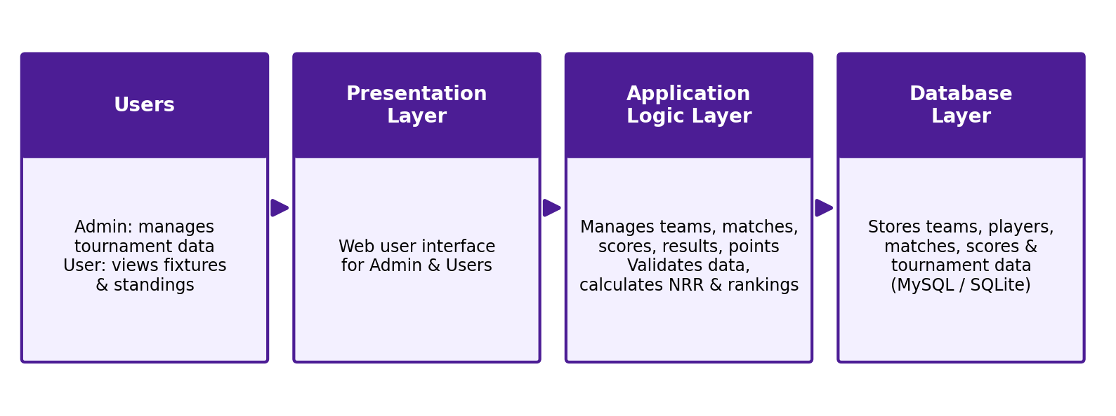
Figure 4.1: High-level system architecture

4.2 Description of Each Layer
Layer | Responsibility
Users | Admin manages tournament data; User views fixtures and standings.
Presentation Layer | Web user interface through which admins and users interact with the system.
Application Logic Layer | Manages teams, matches, scores, results and points; validates data; calculates NRR and rankings.
Database Layer | Stores teams, players, matches, scores and tournament data in MySQL / SQLite.
Benefits: efficient data management, security and easy maintenance. Because each layer has one responsibility, the interface can be redesigned or the database engine replaced without rewriting the calculation logic.

4.3 Deployment Architecture
In the current version the system is deployed locally: the application runs on a laptop (Windows / Linux), the database is a local MySQL or SQLite instance, and the interface is opened in a browser (localhost:3000 in the demonstration). Because the layers are separate, the same architecture can be moved to a cloud host with the database on a managed service. Details are given in Chapter 9.

CHAPTER 5 – DESIGN

5.1 Existing vs Proposed System
Feature | Existing System | Proposed System
Data Storage | Paper, notebooks and separate files | Centralized relational database
Calculations | Manual points, wins and NRR | Automatic results, points and NRR
Updates & Search | Slow; records hard to find | Fast CRUD operations and search
Standings | Hard to produce accurately | Auto-generated points table and rankings
Limitation / Gap | Duplication, errors, lost records | Validated, organized, consistent data

5.2 ER Diagram / Database Schema
The conceptual ER diagram below shows the seven core entities and their relationships. A team has many players (1:N); a tournament has many matches (1:N); a venue hosts many matches (1:N); teams and matches are related many-to-many (N:M) because each match involves two teams and each team plays many matches; a match has many score records (1:N); and the points table links a tournament with its teams.
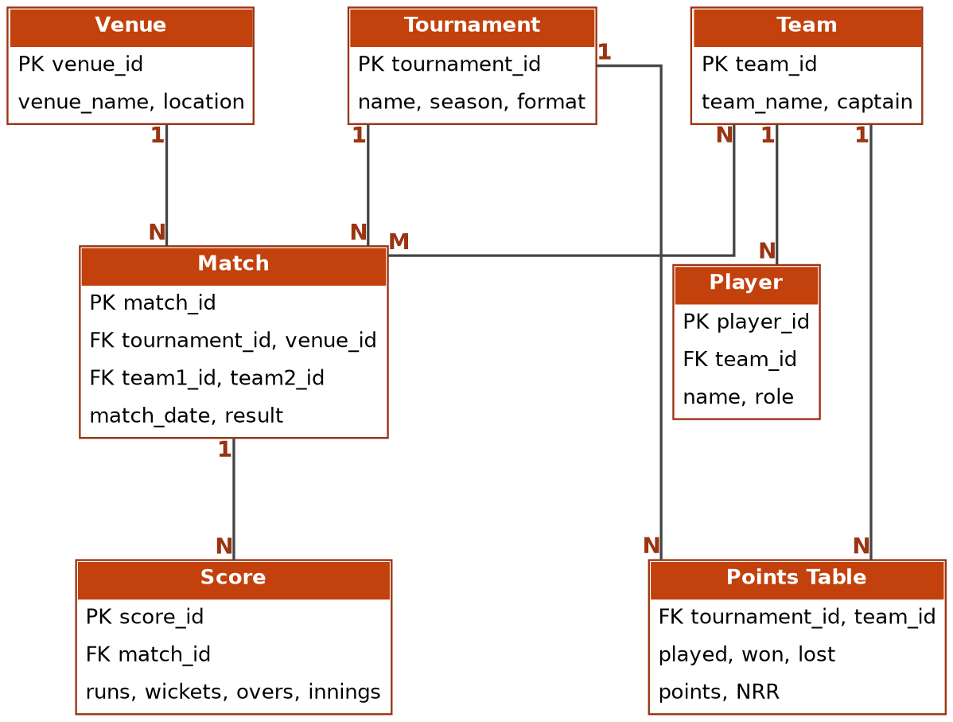
Figure 5.1: ER diagram of the Cricket Tournament Management System

Implemented 13-table schema
In the implemented application the conceptual model is refined into a normalized 13-table schema, shown on the Database Design page of the application (Figures 5.2 and 6.5). Many-to-many relationships are resolved through bridge tables (tournament_teams and tournament_squads), and ball-by-ball data is stored at the finest granularity in the deliveries table so that scorecards and statistics can be derived from it.
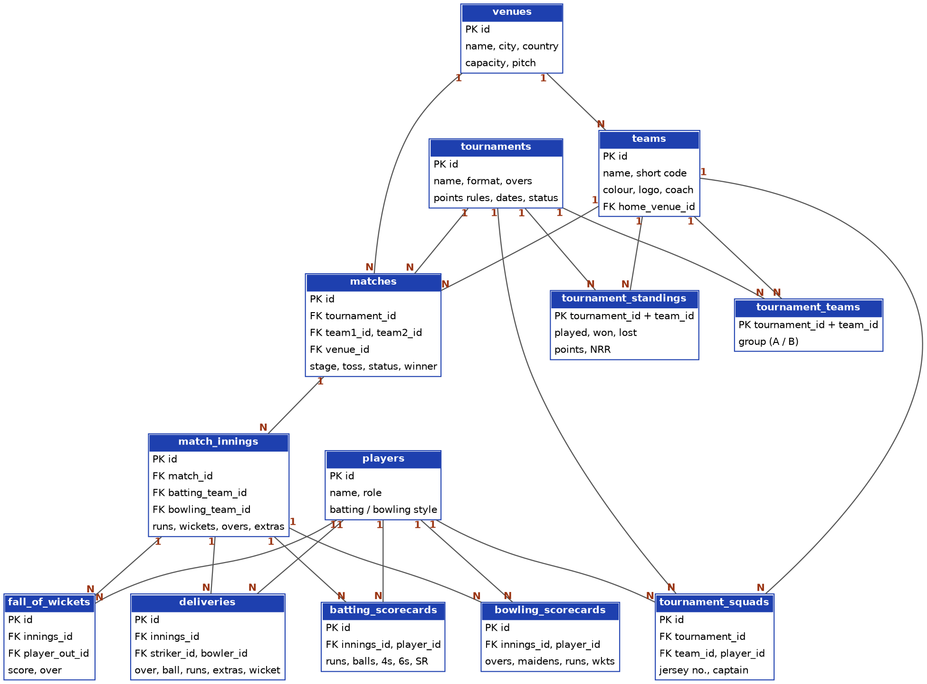
Figure 5.2: Relational schema of the 13 tables (1 : N relationships)
Table | Primary key | Purpose / foreign keys
tournaments | id | Tournament metadata, format (T20/ODI/Test), overs, points rules, dates and status.
venues | id | Stadium facilities, city, country, spectator capacity and pitch characteristics.
teams | id | Franchises/clubs, short codes (CSK, MI), brand colours, logos, head coaches. FK: home_venue_id → venues.id.
tournament_teams | (tournament_id, team_id) | Many-to-many bridge enlisting teams in tournaments with group assignment (Group A, Group B). FKs: tournament_id, team_id.
players | id | Player registry: batting style (RHB/LHB), bowling style, primary role, bio details.
tournament_squads | id | Official squad roster linking players to teams with jersey numbers and captain tags. FKs: tournament_id, team_id, player_id.
matches | id | Fixtures, stage (League, Semis, Final), toss result, match status, winner and margin. FKs: tournament_id, team1_id, team2_id, venue_id.
match_innings | id | Per-innings scorekeeping (Innings 1, Innings 2, Super Over): runs, wickets, overs, extras breakdown. FKs: match_id, batting_team_id, bowling_team_id.
deliveries | id | Ball-by-ball record: over, ball, striker, bowler, runs, extras, wickets, commentary. FKs: innings_id, bowler_id, striker_id.
batting_scorecards | id | Aggregated batting statistics per batter per innings (runs, balls, 4s, 6s, strike rate, dismissal). FKs: innings_id, player_id.
bowling_scorecards | id | Aggregated bowling statistics per bowler per innings (overs, maidens, runs, wickets, economy). FKs: innings_id, player_id.
fall_of_wickets | id | Timeline of wicket dismissals (score, over, batsman out). FKs: innings_id, player_out_id.
tournament_standings | (tournament_id, team_id) | League standings cache: played, won, lost, points and mathematically computed NRR. FKs: tournament_id, team_id.

Normalization: every table stores facts about a single entity, non-key attributes depend only on the key, and repeated values (for example team names in match rows) are replaced by foreign keys. This removes duplication and prevents update anomalies.

CHAPTER 6 – IMPLEMENTATION

6.1 Module-wise Implementation

Admin Module
- Create, read, update and delete tournaments, teams, players, squads, venues and fixtures, with validation.
- Live Scorer console: select a match, record each delivery, rotate strike, change bowler, undo the last ball and open the full scorecard.

User Module
- Dashboard summarizing the current tournament and live match.
- Fixtures & Schedule, Points Table, Leaderboards and Teams & Squads pages for viewing data.

Calculation Module
- Determines the result of each completed match and updates wins, losses, points, NRR and rankings.

6.2 Front-end Logic
The interface is a single-page web application: selecting a navigation tab swaps the content area without reloading. The current tournament and match are held as application state, so changing the selected tournament refreshes every page. In the Live Scorer, the keypad buttons (0, 1, 2, 3, 4, 6, Wide, No Ball, Leg Bye, Bye and Out) send a delivery to the back end, and the scoreboard, current run rate, active batsmen and active bowler update immediately from the response.
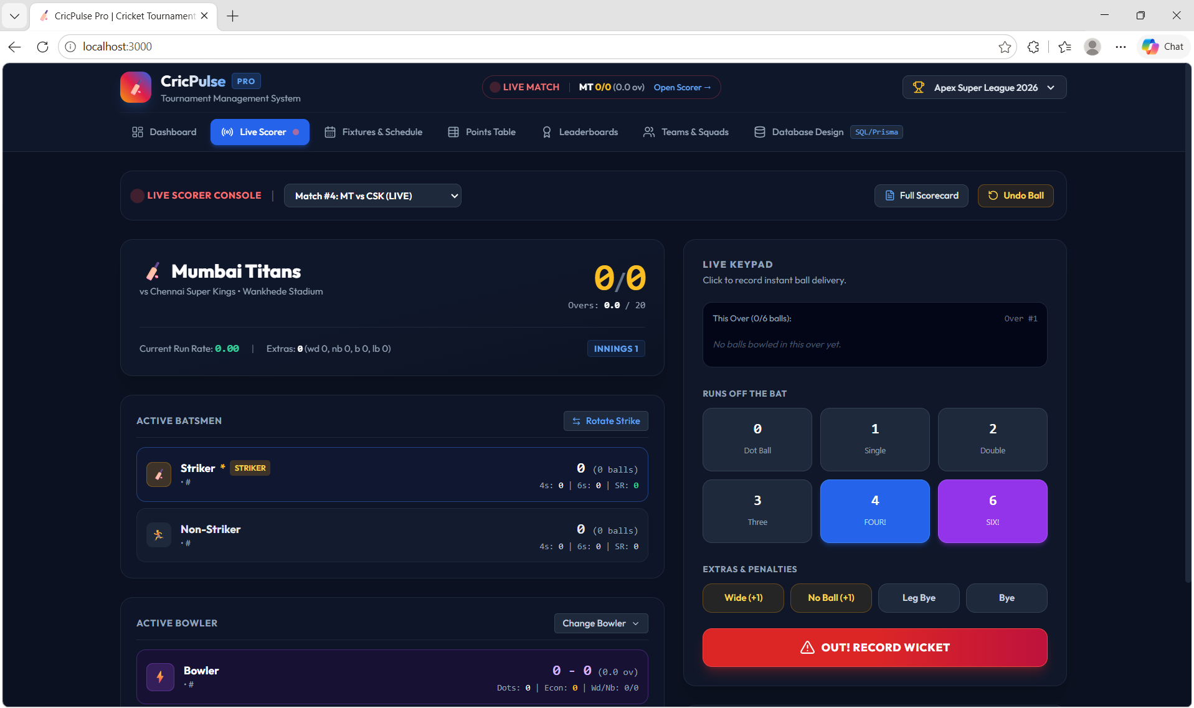
Figure 6.1: Live Scorer console – ball-by-ball score entry (keypad, extras, wicket and undo)

Dashboard, Fixtures, Points Table, Leaderboards and Squads pages
The Dashboard (Figure 6.2) is the “Official Tournament Hub”. It shows the live match with the current score, batsmen on strike, current bowler and the last over, together with summary tiles (franchises enlisted, total runs, total sixes, wickets fallen) and shortcuts to the Live Scoring Console and the DB schema. The Fixtures & Schedule page (Figure 6.3) lists matches with filters (All, Live, Upcoming, Completed) and provides the buttons Generate Round Robin and Schedule Match; each match card shows a Scorecard button and either Live Scorer or Start Match. The Points Table (Figure 6.4) shows position, played, won, lost, tied, no result, points, NRR and recent form, with tabs for All Groups, Group A and Group B. The Teams & Squads page (Figure 6.6) shows franchise cards with home ground, head coach and key squad members, and an Add New Franchise button.
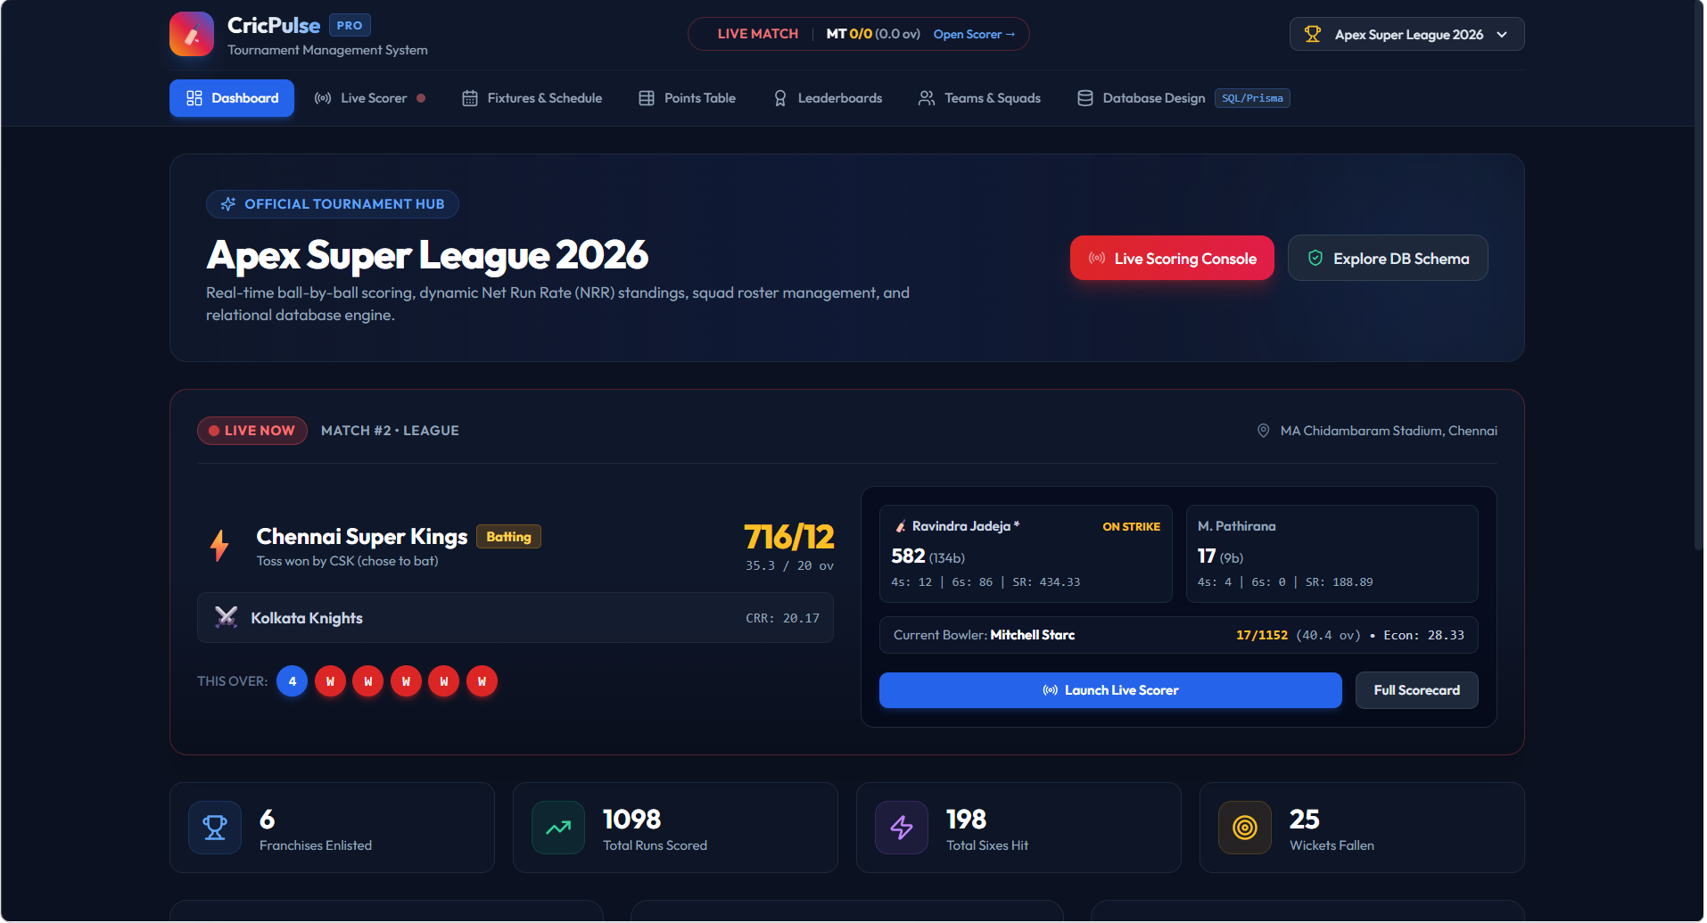
Figure 6.2: Dashboard – Official Tournament Hub with live match
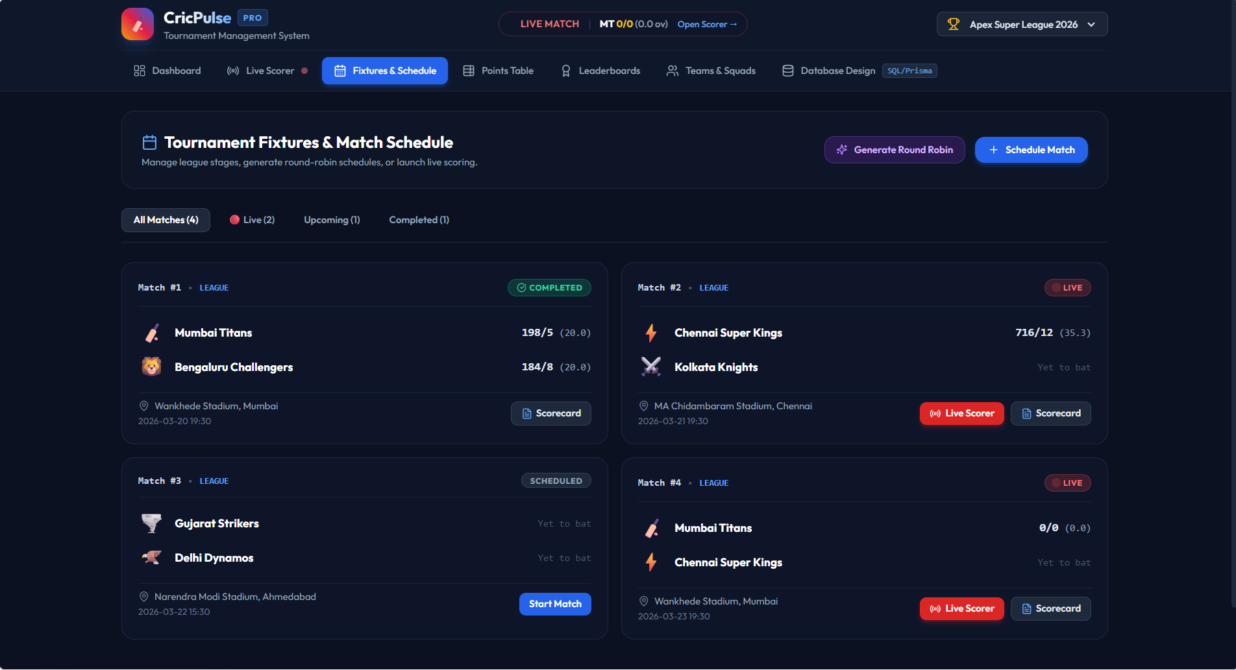
Figure 6.3: Fixtures & Schedule – round-robin generation and match cards
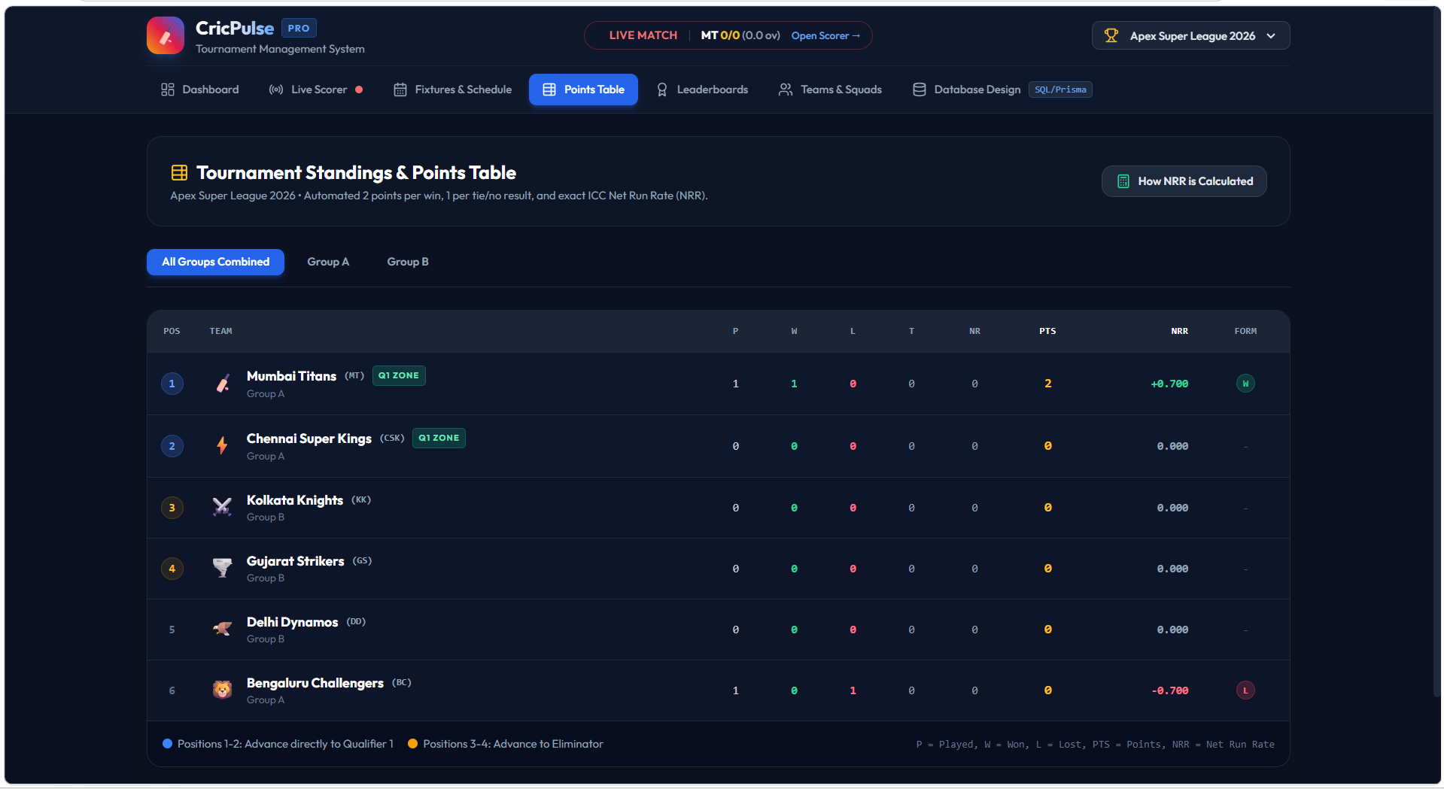
Figure 6.4: Points Table – automated 2 points per win, 1 per tie/no result, with NRR
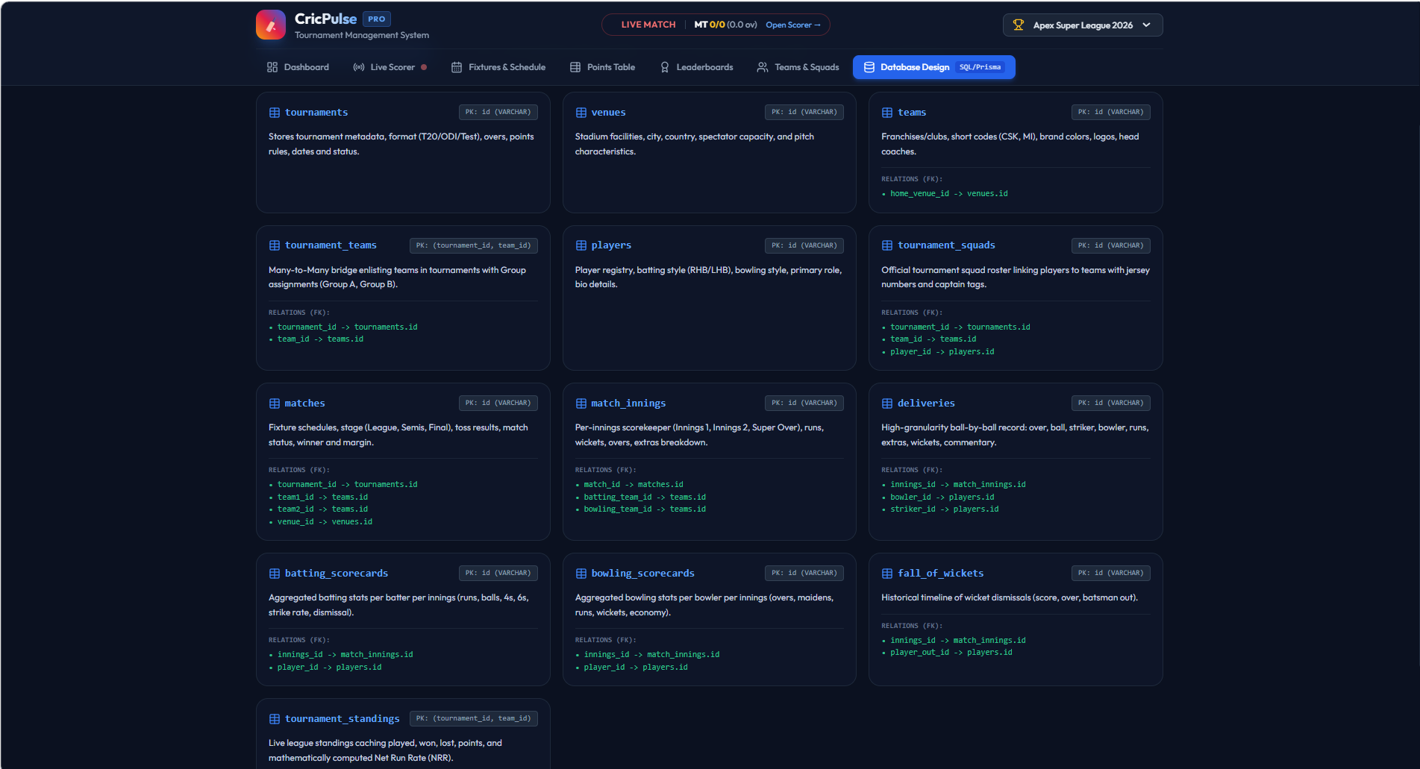
Figure 6.5: Database Design page – all 13 tables with primary keys and foreign-key relations
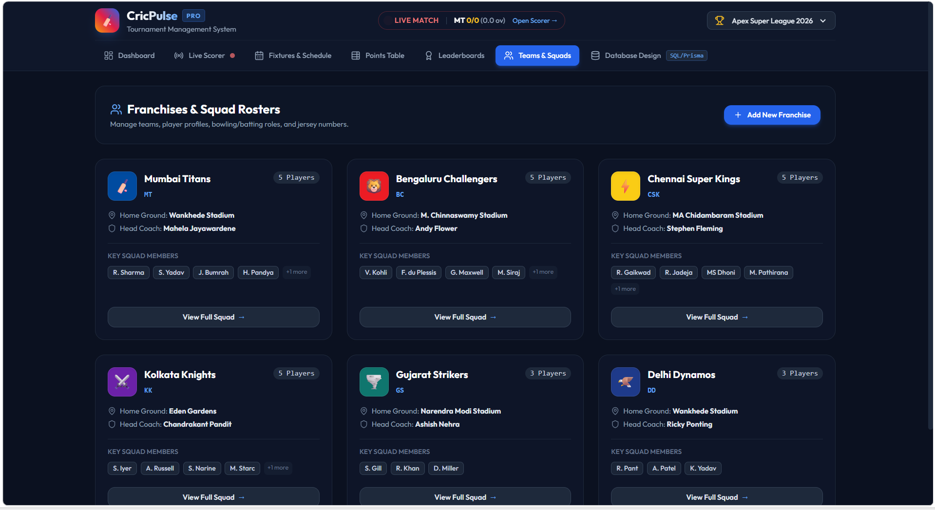
Figure 6.6: Teams & Squads – franchises and squad rosters

6.3 API Integration
The presentation layer communicates with the application-logic layer through API requests. The main endpoints are listed below.
Method | Endpoint | Description
GET | /api/teams | List all teams
POST | /api/teams | Create a team
PUT | /api/players/:id | Update a player
DELETE | /api/matches/:id | Delete a fixture
POST | /api/matches/:id/deliveries | Record a ball in the live scorer
GET | /api/tournaments/:id/points-table | Get standings with NRR

6.4 Authentication & Authorization
Two roles are defined. Admin accounts can create, edit and delete data and use the Live Scorer. User accounts are read-only and can view fixtures, scores and standings. The intended design is that write operations are restricted to the Admin role so that a viewer cannot modify tournament data; test case TC12 (Chapter 8) shows that this restriction is not yet fully enforced, and it is listed as a known limitation in Section 10.3.

6.5 Automatic Calculations (Points and NRR)
After a match is completed, the application logic derives the result from the two innings and updates the points table:
- Played / Won / Lost: played is incremented for both teams; the team with more runs gets a win and the other a loss.
- Points: awarded according to the rules stored with the tournament. In the Apex Super League 2026 the rule is 2 points per win and 1 point per tie / no result.
- Net Run Rate: NRR = (total runs scored ÷ total overs faced) − (total runs conceded ÷ total overs bowled), accumulated over all the team's matches.
- Ranking: teams are ordered by points, with NRR used to break ties.
- Qualification zones: positions 1–2 advance directly to Qualifier 1 and positions 3–4 advance to the Eliminator, as shown beneath the points table.
- Form: the last results of each team are shown as W / L markers.
Because these values are computed from the stored scores, correcting a mistaken delivery automatically corrects every dependent figure.

CHAPTER 7 – FEATURES

7.1 List of Main Features
- Centralized storage of teams, players, venues, matches and scores.
- Fast CRUD operations and search with validation.
- Fixture and schedule management.
- Live ball-by-ball scorer with undo.
- Automatic results, wins, losses, points, NRR and rankings.
- Auto-generated points table and leaderboards.
- Role-based access for Admin and User.
- Round-robin fixture generation and match scheduling.
- Leaderboards: Orange Cap (most runs), Purple Cap (most wickets), Most Sixes and Highest Individual Score.
- Group-wise points table with qualification zones (Qualifier 1 / Eliminator) and team form.
- Franchise and squad management (home ground, head coach, jersey numbers, captain).
- Database Design page showing the 13-table schema, schema.sql, schema.prisma and analytical SQL queries.

7.2 How Each Feature Works
Feature | User perspective | Technical description
Team & player management | Admin fills a form to add or edit a team or player. | Request is validated, then inserted or updated with foreign keys (e.g. player.team_id).
Fixtures & schedule | Admin picks two teams, a venue and a date; users see the list. | A row is added to matches linked to tournament, venue and both teams.
Live scorer | Admin taps the keypad for each ball; scoreboard updates. | Each tap stores a row in deliveries; innings totals and run rate are recomputed.
Points table | User opens the Points Table tab and sees ranked teams. | Standings are calculated from completed matches and ordered by points and NRR.
Leaderboards | User chooses Orange Cap, Purple Cap, Most Sixes or Highest Score tab. | Aggregate queries (SUM, COUNT, GROUP BY) over batting and bowling scorecards and deliveries.
Round robin generator | Admin clicks Generate Round Robin to create all league fixtures. | Every pair of teams in the group is paired once and inserted into matches with a date and venue.
Teams & squads | User browses franchise cards; admin adds a franchise. | Reads teams, venues and tournament_squads; insert into teams and tournament_squads.
Database design view | Evaluator inspects tables and SQL. | Schema is displayed from the SQL and Prisma definitions.

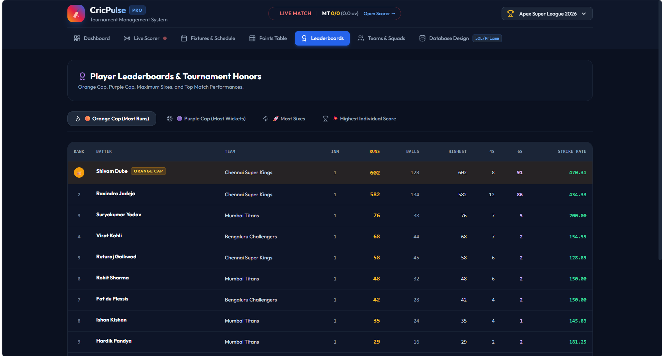
Figure 7.1: Leaderboards – Orange Cap (most runs) with 4s, 6s and strike rate

CHAPTER 8 – TESTING

8.1 API Testing (Postman)
Each API endpoint was exercised with Postman to confirm that valid requests return the expected data and that invalid requests are rejected with a clear error. Requests covered creation, retrieval, update and deletion of teams, players, fixtures and scores, as well as retrieval of the points table.

8.2 Integration Testing
Integration testing checked that the three layers work together: an action in the interface reaches the application logic, changes the database, and the change is visible on the other pages. The most important integration scenario is the complete flow of scoring a match and then confirming that the result, points and NRR on the Points Table are updated correctly.

8.3 Tools Used for Testing
- Postman – API requests and responses.
- Web browser developer tools – interface behaviour and network calls.
- SQL client / console – verifying stored rows and constraint behaviour.

8.4 Test Cases and Results
The table below lists each test case with its expected result and the outcome observed.
ID | Test case | Input | Expected result | Result
TC1 | Add a team | Valid team name and captain | Team saved and shown in Teams list | Pass
TC2 | Add team with empty name | Empty name | Rejected with validation message | Fail
TC3 | Add player to team | Name, role, team | Player linked to the team | Pass
TC4 | Schedule a match | Two teams, venue, date | Fixture appears in Fixtures list | Pass
TC5 | Same team on both sides | Team A vs Team A | Rejected as invalid fixture | Fail
TC6 | Record a boundary | Tap “4” in live scorer | Runs +4; ball counted; run rate updated | Pass
TC7 | Record a wide | Tap “Wide” | 1 extra added; ball not counted | Pass
TC8 | Undo last ball | Tap “Undo Ball” | Previous delivery removed; totals restored | Pass
TC9 | Complete a match | Finish both innings | Result, wins/losses and points updated | Pass
TC10 | NRR calculation | Two completed matches | NRR matches manual calculation | Fail
TC11 | Points rule | Win / tie / no result | 2 / 1 / 1 points awarded | Pass
TC12 | Viewer write attempt | User role tries to edit | Action denied | Fail

Summary of results: 8 of the 12 test cases passed. Adding teams and players, scheduling matches, the live scorer (boundary, wide and undo), match completion and the points rule (2 points per win, 1 per tie / no result) worked as expected. Four cases did not meet the expected result: TC2 (a team with an empty name was not rejected), TC5 (a fixture with the same team on both sides was not rejected), TC10 (NRR did not match the manual calculation) and TC12 (a viewer write attempt was not denied). These are recorded in Section 10.3 as known limitations to be fixed.

CHAPTER 9 – DEPLOYMENT

9.1 Steps to Deploy
- Install the required software (Python / Java / C++ toolchain, MySQL or SQLite, and a web browser).
- Download or clone the project from the GitHub repository.
- Create the database and run the schema script (schema.sql) to create the 13 tables.
- Insert any initial data (for example a sample tournament, teams and venues).
- Install the project dependencies and configure the database connection.
- Start the application and open it in a web browser such as Google Chrome at http://localhost:3000/ (page title: “CricPulse Pro | Cricket Tournament Management System”).

9.2 Environment Configuration
Setting | Description
Database connection | Host, port, database name, user and password (or SQLite file path) stored in a configuration / environment file.
Application port | Port on which the application listens (3000 in the demonstration, URL http://localhost:3000/).
Operating system | Windows or Linux.
Secrets | Credentials kept out of the source repository.

9.3 Hosting of Front-end and Back-end
For the PBL demonstration the application is hosted locally and accessed in the browser at http://localhost:3000/ (CricPulse Pro | Cricket Tournament Management System). This address works only on the machine running the application. For wider access, the application can be hosted on any cloud platform that supports the chosen back-end language, with the database on a managed MySQL service and the interface served from the same host or a static host.

CHAPTER 10 – CHALLENGES & LIMITATIONS

10.1 Issues Faced During Development
- Designing a schema that could represent ball-by-ball data and still support match-level and tournament-level statistics.
- Calculating NRR correctly, especially when overs are fractional (for example 17.3 overs) or a team is bowled out early.
- Handling extras (wides and no-balls) that add runs but do not count as legal deliveries.
- Keeping scores consistent when the scorer needs to undo a mistaken ball.
- Coordinating work among three team members on the same code base.

10.2 Solutions Applied
- A normalized 13-table schema with a deliveries table as the lowest level of detail; all totals are derived from it.
- Overs are converted to balls before NRR is calculated, then converted back for display.
- Extras are stored with the delivery and flagged as non-legal balls, so the over counter ignores them.
- An Undo Ball function removes the last delivery and recomputes totals.
- Git and GitHub were used for branching, merging and tracking changes.

10.3 Current Limitations or Known Bugs
- Scores update when the page requests them; there is no push-based real-time update for viewers yet.
- No player statistics or analytics dashboards beyond leaderboards.
- No mobile application; the web interface is the only client.
- Input validation is incomplete: a team with an empty name and a fixture with the same team on both sides are accepted (TC2, TC5). Cricket limits such as no more than 10 wickets per innings and realistic run totals should also be enforced; some sample live-match data in the screenshots exceeds them.
- The NRR result did not match the manual calculation in testing (TC10) and needs to be re-verified.
- Role-based restriction is not fully enforced: a viewer write attempt was not denied (TC12).
- Rules such as DLS (rain-affected matches) are not supported.

CHAPTER 11 – FUTURE ENHANCEMENTS

11.1 Planned Features
- Live score updates and match notifications so followers are informed of wickets, milestones and results.
- Player statistics and performance analytics, such as batting averages, strike rates, economy rates and trend charts.
- Mobile app for fans and team managers.

11.2 Possible Integrations or Optimizations
- Push notifications and WebSocket-based real-time updates.
- Database indexing and caching of the points table for large tournaments.
- Support for DLS and super-over rules.
- Export of scorecards and standings as PDF or Excel.
- Cloud hosting with automated backups.

CHAPTER 12 – CONCLUSION

12.1 Summary of the Project
The Cricket Tournament Management System replaces paper and spreadsheet records with a centralized relational database and a web interface. Administrators manage teams, players, fixtures and scores, while users view fixtures, scorecards and standings. The system calculates results, points, wins, losses, NRR and rankings automatically.

12.2 What Was Achieved
- A normalized 13-table database design covering the full tournament life cycle.
- A layered web application with Admin and User modules.
- A ball-by-ball live scorer with undo.
- Automatic points table and rankings.
- Reduced manual work and errors, with improved accuracy and accessibility of tournament data.

12.3 Skills Learned During Development
- Relational database design: ER modelling, normalization, keys and constraints.
- Writing SQL, including aggregate queries for statistics.
- Layered backend development and API design.
- Testing with Postman and integration testing.
- Team collaboration with Git and GitHub, and technical documentation.

CHAPTER 13 – REFERENCES

Documentation
[1] MySQL 8.0 Reference Manual. Oracle Corporation. Retrieved from https://dev.mysql.com/doc
[2] SQLite Documentation. Retrieved from https://sqlite.org/docs.html
[3] Python Documentation. Python Software Foundation. Retrieved from https://docs.python.org

Books
[4] Silberschatz, A., Korth, H. F., & Sudarshan, S. Database System Concepts (7th ed.). McGraw-Hill Education.
[5] Elmasri, R., & Navathe, S. B. Fundamentals of Database Systems (7th ed.). Pearson.
[6] Sommerville, I. (2016). Software Engineering (10th ed.). Pearson Education.

CHAPTER 14 – APPENDICES

A. Screenshots of the Application
Screenshots of all seven pages are provided in Chapters 6 and 7 (Figures 6.1 to 6.6 and 7.1). The complete 13-table schema view is repeated below for reference.
Database Design – complete 13-table schema model

B. Installation / Setup Instructions
See Section 9.1. Application URL (local): http://localhost:3000/. Source code: GitHub repository (QR code on the project poster).

C. User Manual
- Admin: log in, create the tournament, add teams and players, schedule fixtures, then open Live Scorer and record each ball.
- User: open the application, choose a tournament, and use the tabs to view fixtures, points table, leaderboards and squads.

D. Geo-tag Photos with Guide

E. Review Forms with Guide Signatures

